**INFO-3111 Summer 2023 – Checkpoint #2**

|  |
| --- |
| **Due:** At the start of class, **12:00 PM (noon), Tuesday, May 14th, 2024** |
| **Submit:** Your screenshot to the submission folder in FOL |
| **Worth/weight/mark value:** approximately 1%  (There will be up to 12 checkpoints, *all together worth 10%*, and the lowest two marks (including marks of zero/no submissions) being dropped (not included in your mark). |

This is the “triangle of death” (the RGB triangle) from checkpoint #1:

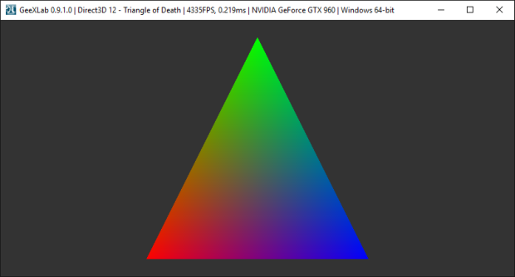

**Now: You need to show one of the “PLY” models as a wireframe.**

There’s a bunch of them under “Some 3D Models” in the git hub repository.   
You can use one of these or some other model you’ve discovered.

**The model needs to be:**

* Rendered as solid, wireframe, or as points. This can be a bit of a mess if it’s *not indexed*.
* Some colour that I can see it (yellow, white, whatever – something bright)
* Scaled and or positioned (or the camera moved) so that it fills most of the window.
* Something “complicated” - *not* a triangle or cube or something like that (or a cow).
* **BONUS 50%:** You show the “indexed model” *properly* (instead of the mess you’ll almost certainly get when you just display the list of vertices as triangles). Remember that you really want to show the *triangles* that index the vertices, so you’d have to make an array of vertices from the triangle (“face”) list.

**Submit a *short* video showing:**

* Visual Studio running with your code.
* Somewhere on the screen it should have your **name** and **student number** and the **date** and **time**.
* The program starting and showing the model - i.e. start in Visual Studio and launch the application.

I use OBS (Open Broadcast), which will record to a file, but there’s many, many other tools.   
You can even record your screen from your cell phone if that’s easier.